WFCS 3 Spot Archery League.
3-Spot Archery League starts 11:00am on 1/8/2026 and 6:00pm on 1/9/2026. 45 arrows. League runs for 12 weeks.
Contact Mike Cummings at 716-655-5030 for information to join the fun.
Cost is $10.00 per week.

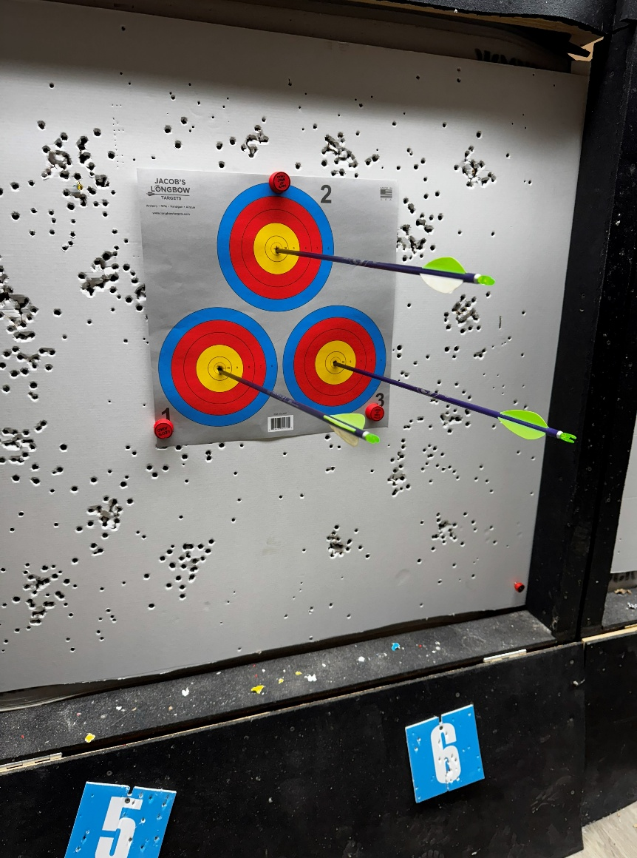

West Falls Conservation Society
55 Bridge St, West Falls NY 14170
Ph:716-652-4650

